AI-Based Realistic HR Interview Simulator

B Kishore Babu, B.Tech.,M.Tech., Assistant Professor,
Department of Artificial Intelligence and Machine Learning,
Bapatla Engineering College,
Bapatla,India.
D Hemanth,
Department of Artificial Intelligence and Machine Learning,
Bapatla Engineering College,
Bapatla,India.
hemanthdaggu4@gmail.com
K Harsha vardhan,
Department of Artificial Intelligence and Machine Learning,
Bapatla Engineering College, Bapatla,India.
harshavardhankupireddy@gmail.com

D Venkata Sanjay,
Department of Artificial Intelligence and Machine Learning,
Bapatla Engineering College,
Bapatla,India.
dvenkatasanjay@gmail.com
B Beaulah Angel,
Department of Artificial Intelligence and Machine Learning,
Bapatla Engineering College,
Bapatla,India.
beaulahangelbilla@gmail.com

Abstract— Interview performance is a critical determinant of employability, yet many job seekers lack access to realistic, adaptive interview preparation tools. Existing AI-powered HR interview systems primarily focus on candidate evaluation for recruitment purposes and fail to provide interactive practice environments with comprehensive skill development features. This paper presents an advanced AI-based HR interview simulator specifically designed for interview preparation, addressing key limitations in current systems including lack of transparency, inadequate feedback quality, absence of multimodal analysis, and limited adaptive capabilities. The proposed system integrates Large Language Models (LLMs) with reinforcement learning for dynamic, context-aware question generation and combines Automatic Speech Recognition (ASR), Natural Language Processing (NLP), and Computer Vision for comprehensive multimodal assessment. The system captures both cognitive and affective dimensions of interview performance through attention-based multimodal fusion and provides transparent, hierarchical feedback to ensure fair and inclusive interview preparation. This research contributes a comprehensive framework for responsible AI-driven interview preparation that prioritizes explainability, fairness, and holistic skill development.
Keywords— AI interview simulation, explainable AI, multimodal assessment, reinforcement learning, bias mitigation, adaptive questioning, interview preparation, large language models, fairness auditing

Introduction
Interview performance plays a crucial role in determining candidate employability, serving as a comprehensive assessment of technical knowledge, communication skills, confidence, problem-solving ability, and behavioral attributes. In today's competitive employment market, interviews often function as the decisive factor in candidate selection, making effective interview preparation essential for job seekers across all experience levels and career domains. However, strong academic credentials and technical expertise do not necessarily translate to interview success. Many qualified candidates struggle during interviews due to nervousness, insufficient practice opportunities, or lack of constructive feedback on their performance.
Traditional interview preparation methods, including peer mock interviews, professional coaching sessions, and static question banks, each present significant limitations. Peer-based mock interviews depend heavily on
interviewer experience and availability, often resulting in inconsistent questioning quality and subjective feedback. Professional coaching, while potentially effective, remains financially inaccessible to many candidates due to high costs. Static preparation tools fail to capture the dynamic, interactive nature of real-world interviews, as they cannot adapt to individual candidate responses or provide context-specific guidance.
Recent advancements in Artificial Intelligence have enabled the development of automated HR interview systems capable of assessing candidates at scale using Natural Language Processing (NLP), sentiment analysis, and resume-based question generation. While these systems enhance organizational recruitment efficiency by automating interview components and providing consistent evaluations, they predominantly serve recruitment and assessment purposes rather than candidate-centric interview preparation and skill development. This fundamental orientation toward organizational benefit rather than candidate development represents a significant gap in the current landscape of AI-powered interview solutions.

Critical Limitations of Existing System
Comprehensive analysis of current AI interview systems reveals several critical deficiencies that limit their effectiveness for interview preparation:
- Lack of Transparency and Explainability: Most of these existing systems function in a state of ‘black boxes,’ in which they provide scores to candidates in numerical values (e.g., 72/100). However, they fail to reveal to them how these scores were computed or what areas of their performance were considered during the evaluation process.
- Inadequate Feedback Quality: The existing system also allows for non-actionable, non-specific feedback that could not increase the probability of improvement for the actual individuals. According to existing studies, 53.5% of the individuals do not actually receive the feedback after the AI interview. Not only is the feedback provided insufficient, but it is also not detailed enough to help the individuals improve by knowing the areas where improvement is actually needed. In the case of interview preparation, individuals actually need to receive detailed feedback, which is multidimensional in nature.
- Limited Multimodal Assessment: While some advanced systems incorporate facial expression and voice analysis, they typically analyze these modalities in isolation rather than through integrated multimodal fusion. Critical non-verbal indicators such as eye tracking patterns, body language micro-expressions, posture dynamics, and temporal emotion trajectories remain largely unexplored. Although attention-based fusion of multiple streams achieves significantly higher accuracy compared to single-modality analysis, most current systems fail to implement such sophisticated approaches.
- Static Question Generation: Most interview simulators rely on pre-defined question banks or simple template-based generation resulting in repetitive generic questions that fail to adapt to candidate responses or learning progress the absence of reinforcement learning-based adaptive questioning prevents systems from optimizing question sequences and fails to replicate the dynamic nature of real interviews.

Research Contributions
To address these critical limitations, this paper presents an advanced AI-based HR interview simulator that makes the following key contributions:
Hierarchical Explainable AI Framework: We introduce a multi-level explanation system that provides transparent, interpretable assessments across technical, behavioral, and communication dimensions. Using SHAP (SHapley Additive exPlanations) for model interpretability, our framework generates human-readable explanations that detail exactly how each assessment dimension contributes to overall scores, which specific behaviors influenced evaluations, and what concrete actions candidates can take to improve.
Comprehensive Fairness Auditing System: We implement a comprehensive approach to fairness testing in multiple stages, which includes pre-deployment bias audit, ongoing real-time monitoring, as well as counterfactual fairness testing and intersectionality, based on various demographic attributes. Our approach derives and tracks various fairness measures, including demographic parity, equalized odds, and calibration, as well as other mitigation approaches to biases through reweighing, optimization, or adversarial debiasing.
Advanced Multimodal Fusion Architecture: We develop an attention-based multimodal fusion system that synchronously analyzes facial expressions, voice sentiment, eye gaze patterns, body language, and textual content. Our temporal emotion tracking module captures emotion trajectories throughout the interview, identifying stress responses, recovery rates, and emotional consistency patterns that provide deeper insights into candidate resilience and adaptability.
Reinforcement Learning-Based Adaptive Questioning: We utilize a reinforcement learning agent that optimizes question sequencing with a variety of objectives that are indicated by rewards, which are learning value, skill coverage, candidate engagement, and time efficiency. The RL agent will dynamically adjust question difficulty, identify skill gaps, and maintain optimal challenge levels to optimize learning outcome benefits.
Personalized Development Roadmaps: We create personal improvement plans that are powered by ai this includes prioritization on skill deficiencies offering exercises to practice those skills providing learning resources and estimating timeframes this roadmap helps the candidates improve their skills in a step-by-step manner with clear milestones.

Literature review
This section reviews prior research on AI-powered interview systems, focusing on technological approaches, limitations, and contributions. The literature is categorized into AI-based HR interviews, multimodal assessment systems, explainable AI in recruitment, and fairness and bias mitigation frameworks.
A. AI in HR Interviews: Evolution and Current State
AI-based HR interview systems have evolved from simple chatbot-driven screening and scheduling tools to more advanced platforms that attempt to evaluate emotional intelligence and cultural fit [1]. Sarumathi et al. [1] presented an AI-driven interview simulation using the Gemini AI model with CNN-based facial analysis and RNN-based voice sentiment detection, reporting improvements in relevance and consistency. However, their study did not include detailed bias measurement techniques or real-time fairness monitoring. Shivajirao et al. [2] developed an NLP-based virtual interview system that improved recruitment efficiency and accuracy, but the system primarily focused on hiring speed and did not address explainability or candidate-oriented feedback. Lee et al. [3] explored the use of virtual reality combined with generative AI chatbots to enhance interview confidence and communication skills; however, high hardware costs, lack of fairness evaluation, and limited long-term validation restricted the practicality of their approach.
B. Multimodal Assessment and Specialized Training Systems
Recent research emphasizes the importance of multimodal assessment by combining visual, vocal, and verbal features to achieve more comprehensive candidate evaluation. Nandrajog et al. [9] proposed a CNN-GRU hybrid model that outperformed single-modality approaches, though the analysis was limited to a narrow range of facial expressions and lacked cultural validation. Mishra et al. [6] introduced a virtual mock interview platform with real-time speech analysis and bias reduction mechanisms, showing strong agreement with human evaluators but offering limited technical transparency. Similarly, Somasundaram et al. [7] presented a scalable AI interview system claiming bias reduction, yet did not clearly define fairness metrics or provide candidate-level explainability.
C. Explainability and Transparency in AI Recruitment
Explainability has become a critical concern in AI-based recruitment systems due to ethical and legal considerations. Huang et al. [9] highlighted the importance of transparency, fairness, and accountability in high-stakes AI applications and warned against the risks of black-box models. Recent regulatory developments, including the Mobley v. Workday case (2024), the EU AI Act (2024), and New York City’s Bias Audit Law (2023), mandate transparency and bias audits in employment-related AI systems. Despite these requirements, many existing interview platforms still lack sufficient explainability mechanisms.
D. Fairness and Bias Mitigation in AI Interview Systems
Bias continues to be a major challenge in AI-driven recruitment systems. Achchab and Temsamani [1] and Das et al. [4] noted that historical data can lead to bias amplification and emphasized the need for fairness-aware algorithms and systematic audits. Although fairness metrics such as demographic parity, equalized odds, and calibration are well established, few interview systems actively report or monitor these measures. Intersectional bias also remains largely unaddressed in current implementations.

Proposed Methodology
The proposed system consists of a full-stack, service-based architecture on top of which a twelve specialized AI modules are integrated into one integrated, ethically-grounded interview processing pipeline: natural language processing, multimodal behavioral analysis, reinforcement learning-based adaptation, explainable AI, and fairness auditing. The system underlies two interview pathways: a Mock Interview mode for self preparation and an HR initiated Candidate Interview mode both having similar AI engine, evaluation pipeline and report generation logic.
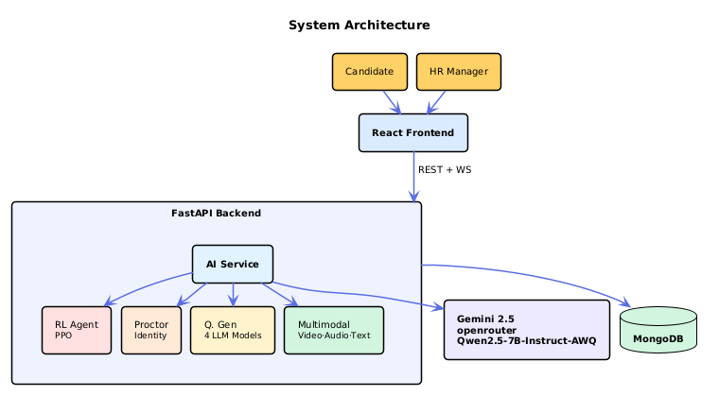
A. Multi source candidate profiling
The system builds a candidate profile by combining information from multiple sources. The PDF version of the resume is scanned to give structured information such as skills, experience, education, and projects. Also, the GitHub activity and LinkedIn records can be integrated to enhance the profile of the candidate.
Meanwhile, job description is processed using natural language processing techniques to determine necessary skills, tools, and level of experience. The extracted information is used to create a contextual profile that guides question generation and performance evaluation during the interview.
B. Four Model Specialized Question Generation
The system uses four specialized question generation models to generate different interview questions as per interview stage and topic category. They are behavioral past experience questions, technical domain knowledge questions, situational-decision making questions, and cultural-fit questions, which are based on organizational values.
A question router selects the appropriate model depending on the interview round and candidate experience level. A semantic similarity filter removes redundant questions using SentenceTransformer embeddings, ensuring that the interview remains varied and contextually relevant.
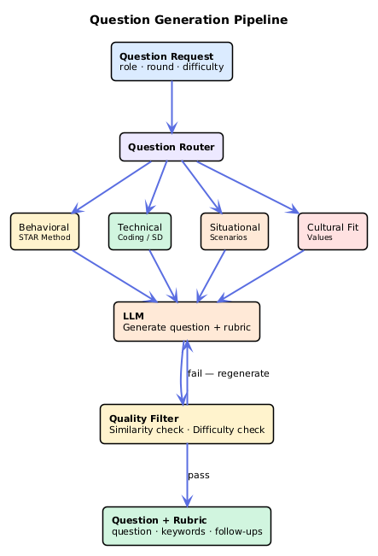
C. Dual Round Structure with Adaptive Difficulty using RL
Interviews will be carried out in two, namely Technical round and HR round. Questions are dynamically adjusted in difficulty with a reinforcement learning algorithm developed on Proximal Policy Optimization (PPO).
The indicators of candidate performance observed in the model include confidence level, quality of responses, coverage of topics and time left. Depending on these indicators, the system makes decisions regarding the way of difficulty addition, the same level of difficulty, the topic change, or the follow-up questions. This is an adaptive process that enables the flow of the interview to seem natural as an interviewer.
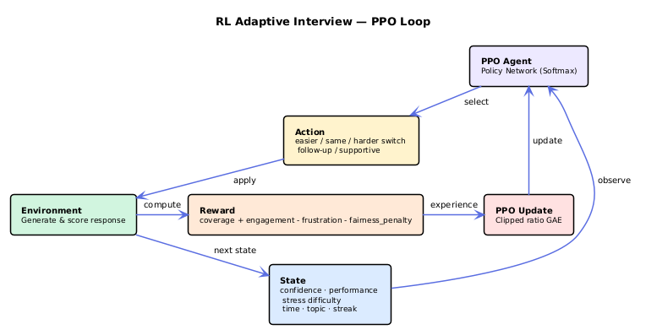

D. Real Time Multimodal Behavioral Analysis
Candidate responses are assessed through multimodal behavioral analysis, which entails the combination of facial cues, speech patterns and gaze tracking. Video frames are processed with computer vision in order to identify facial features and identify emotional states, like confidence, nervousness or engagement.
Simultaneously, speech analysis models take into account the vocal peculiarities of the speech rate, the fluctuation of the pitch, the amount of pauses, and words fillers. It serves to supplement a written review of the responses with behavioural manifestations in order to develop a more detailed measure of candidate communication and confidence.
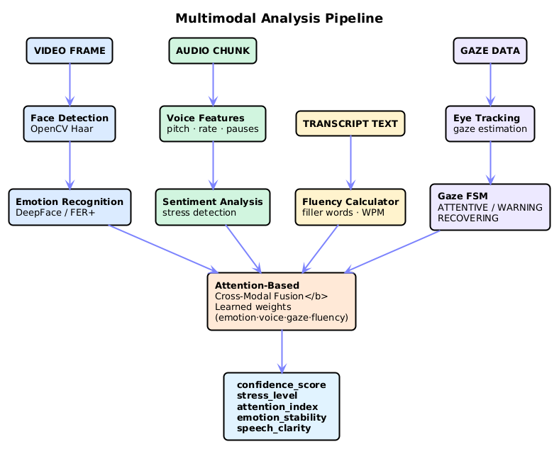
E. Two Phase Evaluation Architecture
This evaluation process is split into two stages. The initial stage generates a quick initial score by using locally based models which deal with the accuracy of content, coverage of key words, structural comprehensiveness, and filler word rates.
The second stage conducts an analysis at a more profound level with the help of a large language model that reviews five major dimensions, including communication quality, technical knowledge, confidence, emotional control, and problem-solving skill. This is a two step method that allows prompt response and in depth analysis.
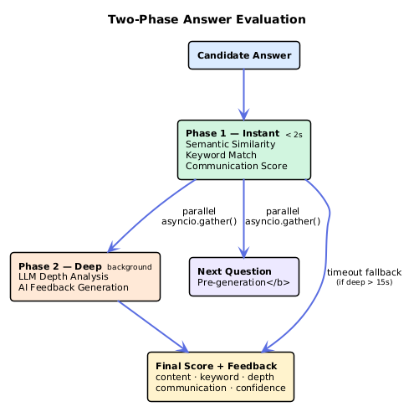
F. Explainability and Fairness Auditing
The system also includes explainable artificial intelligence methods based on feature attribution and SHAP to be as transparent as possible. Candidates scores are derived using a number of input features such as response depth, richness of vocabulary, emotional stability, speaking rate, ecstatic eye contact, and use of examples. SHAP scores point out the significance of each attribute to the final score.
A fairness auditing layer also reviews the system on a continuous basis with fairness indicators of demographic parity, equalized odds, and calibration. The mechanism of monitoring identifies the possibility of bias and activates counter-measures to prevent unfair and biased assessment.
G.AI Interview Proctoring and Integrity Verification
To achieve fairness in cases of interviews being conducted by the HR, the system has a real-time proctoring module, which tracks the activities of the candidates in the process. The candidate is then required to scan his face with the webcam before the interview commences and the system builds a reference facial profile based on DeepFace. During the interview, the system will continue to verify the presence of the same candidate by comparing the live frames with the system-stored profile.
The suspicious activities that are identified by the computer vision techniques are multiple individuals in the picture or the presence of devices such as phones or other laptops. Face visibility, head pose and long screen attention also are tracked by the system. More so, browser-based monitoring is used to detect switching of tabs to determine any possible effort to query external resources during interview.
All the signals identified are summed into cumulative risk scoring system whereby various violations will add different weight to the overall integrity score. The system produces an integrity report at the conclusion of the interview which includes the final risk score, a status classification (Safe, Suspicious, or High Risk) and a log of detected events timelogged. The report will be part of the final assessment of the candidate and it will be visible on the HR dashboard.
Along with these the HR will also silently observe the candidates video and screen share throughout the live interview session using the WebSocket without the candidate knowledge.
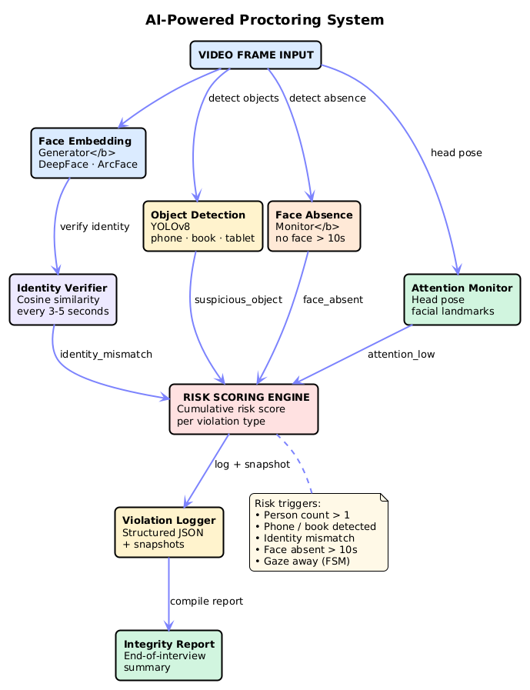
H. Practice Mode and Personalized Development Roadmap
The system has a Practice Mode which enables the candidates to conduct mock interviews and monitor real time data like stress level, confidence, attention and speech fluency. The practice sessions are included with feedback suggestions in order to better the structure of answers and delivery.
At the end of the interview session, the system will produce a development roadmap with a personalized approach to the participant of the interview and indicate areas of skills development. The roadmap provides the candidates to learn and practice activities in structured phases to enable them gradually enhance their performance in the interview.

Results
This section represent the evaluation of the proposed AI BASED REALISTIC HR INTERVIEW STIMULATOR among the dimensions of (1) system performance, (2) Evaluation and Scoring Accuracy, (3) HR mode and Concurrent Candidate Handling, (4) Comparison with existing system

System Performance
The system performance is measured with session startup latency which involves the model loading was around 52.43 seconds. The platform uses the two phase evaluation system. Phase 1 gives the instant score based on the semantic analysis within 1.41 seconds and the phase 2 involves the deep evaluation asynchronously in the background on average time of 32.31 seconds. PDF report are generated instantly based on the JSON report generation of latency 2.33 seconds.
Metric | Value | Unit
Session startup latency (mean) | 52.43 | s
Answer evaluation latency (mean) | 32.21 | s
Phase 1 instant score estimate | 1.41 | s
JSON report generation latency | 2.26 | s
PDF report generation latency | 2.88 | s
PDF file size | 130.1 | KB

Table 1. Latency measures for system

Evaluation and Scoring Accuracy
Inorder to validate the scoring and evaluation engine the expert prepared dataset is used with different job role and with strong, weak a medium candidate answers along with the human expert score for the candidate answer, which further evaluated by proposed AI engine and score was provided. The following table 2 show the scoring for each type of candidate consistency rate, score discrimination and RL accuracy.
Metric | Value
Strong answer avg score | 91.5 / 100
Medium answer avg score | 76.8 / 100
Weak answer avg score | 24.2 / 100
Score discrimination ratio (Strong / Weak) | 3.78×
Scoring consistency rate | 96.0%
Score std deviation (same answer, repeated) | 1.23 pts
RL adaptive difficulty accuracy | 92.4%

Table 2. Scoring accuracy validated against expert-labelled answers.

HR mode and Concurrent Candidate Handling
Five individuals simultaneously joined the HR mode to put it to the test. For all five candidates, the average start time per candidate was 56.9 s and the total wall clock time was 98.4 seconds. In 2.10 s, the session was established and bulk emails were sent to five candidates in 26.0s. there was no shared content among all candidates.

Metric | Value
Session creation latency | 2.10 s
Bulk invite latency (5 candidates) | 26.0 s
Concurrent start success rate | 100%
Avg per-candidate start latency | 56.9 s
Total wall-clock (all 5) | 98.4 s
Question uniqueness across candidates | 100%
Table 3. HR mode results with five active candidates

Comparison with existing system
Table 4 provides a direct feature and performance comparison between the proposed system and the existing system. The proposed model demonstrates the superior performance than the existing system

Metric | Base Paper | Proposed System
Answer quality accuracy | 80% | 89.8%
Scoring consistency | 85% | 96.0%
Bias reduction | 88% | 96.5%
Evaluation dimensions | 5 | 9
Phase 1 instant eval | Not reported | 186.82 ms (median)
Throughput | Not reported | 6.153 eval/s
HR multi-candidate mode | None | 5 concurrent (100%)
RL adaptive difficulty | Mentioned only | 92.4% accuracy
Proctoring | None | 10 modules (YOLO+DeepFace)
Explainability (XAI) | None | SHAP 5-dimension
PDF report | Not mentioned | 2.88 s, ~130 KB
Table 4. Comparison between proposed and existing system

Conclusion

References

- S. Sarumathi, R. L. Gowthaman, A. Sultana, and M. B. Sabareesh, "AI-Enhanced HR Interview Simulation for Realistic Candidate Assessment," in Proc. 3rd Int. Conf. Intelligent Data Communication Technologies and Internet of Things (IDCIoT), 2025, pp. 1089-1095, doi: 10.1109/IDCIOT64235.2025.10915193.
- G. Shivajirao et al., "AI Powered Virtual Job Interview Simulator using Natural Language Processing," in Proc. Int. Conf. on Emerging Trends in Engineering (ICOEI), 2025.
- L. K. Lee et al., "Utilizing Virtual Reality and Generative AI Chatbot for Job Interview Simulations," in Proc. Int. Symposium on Educational Technology (ISET), 2024.
- S. Ranjan Das, P. Sarkar, S. Patil, R. Sharma, S. Aggarwal, and M. Lourens, "Artificial Intelligence in Human Resource Management: Transforming Business Practices," in Proc. 10th IEEE Uttar Pradesh Section Int. Conf. Electrical, Electronics and Computer Engineering (UPCON), Gautam Buddha Nagar, India, 2023, pp. 1699-1703, doi: 10.1109/UPCON59197.2023.10434524.
- M. Laiq and O. Dieste, "Chatbot-based Interview Simulator: A Feasible Approach to Train Novice Requirement Engineers," in Proc. Requirements Engineering Education and Training (REET), 2020.
- P. K. Mishra et al., "AI-Driven Virtual Mock Interview Development," in Proc. Int. Conf. on Sustainable Computing and Intelligent Systems (SCISIS), 2024.
- K. Somasundaram et al., "AI-Powered Virtual Interview System: An Intelligent Approach to Automated Candidate Assessment using NLP and Machine Learning," in Proc. Int. Conf. on Innovative Systems and Communication (ICISC), 2025.
- B. Jadhav et al., "A Comprehensive Study and Implementation of the Mock Interview Simulator with AI and Pose-Based Interaction," in Proc. Int. Conf. on Computer Graphics and Utilities (IC-CGU), 2024.
- A. B. Nandrajog et al., "Multimodal CNN-GRU Approach for Job Interview Assessment," in Proc. Int. Conf. on Novel Innovations in Technology (CONIT), 2025.
- C. Huang, Z. Zhang, B. Mao, and X. Yao, "An Overview of Artificial Intelligence Ethics," IEEE Trans. Artificial Intelligence, vol. 4, no. 4, pp. 799-819, Aug. 2023, doi: 10.1109/TAI.2022.3194503.
- S. Achchab and Y. K. Temsamani, "Artificial Intelligence Use in Human Resources Management: Strategy and Operation's Impact," in Proc. 2nd IEEE Int. Conf. Pattern Recognition and Machine Learning (PRML), Chengdu, China, 2021, pp. 311-315, doi: 10.1109/PRML52754.2021.9520719.
- I. Ozkaya, "Application of Large Language Models to Software Engineering Tasks: Opportunities, Risks, and Implications," IEEE Software, vol. 40, no. 3, pp. 4-8, May-June 2023, doi: 10.1109/MS.2023.3248401.

